TutoConnect Software Testing Document

Software Testing Document
  - Sprint 1
  - Section 7, Group 4 | Principles of Software Engineering
Document Type | Software Testing Document, Sprint 1
Testing Type | User Acceptance Testing
Testing Approach | Testers view all screens and verify that visible UI elements match what is expected. No backend or data entry is performed during the test. System and integration testing are not applicable to static prototypes.
Mockup Screens | Splash Screen, Sign In, Registration (role selector), Student Registration, Tutor Registration, Recover Password, OTP Entry, Update Password, Search Page, Filtered Results, Filter Popup, Language Dropdown, Subjects Dropdown, Study Level Dropdown, Side Menu
Roles Evaluated | Student, Tutor
Version | 1.0

Contents
Cover Page 1
Introduction 3
Purpose 3
Methods 3
Mockup Screens Referenced 3
User Acceptance Testing 4
User Feedback 9
Collection Method 9
Sprint 1 Feedback Form Results 9

Introduction

Purpose
This document records the results of User Acceptance Testing done on the TutoConnect Sprint 1 prototype mockups. The prototype consists of static screen designs showing the intended UI for each Sprint 1 feature. Tessting is performed by inspecting each screen and verifying that the correct elements are present and functional.
System and integration testing are not conducted at this stage. These testing types require a live backend where flows can be triggered and class interactions can be observed.

Methods
The tester opens the relevant mockup screen and observes what is visible. Each test case states which screen to observe, what elements should be visible based on user stories, and what was observed on the mockup. A pass means that all expected elements are present. A fail meants one or more required elements are missing from the mockup.

Mockup Screens Referenced
- Splash Screen
- Sign In page
- Registration page (role selector)
- Student Registration page
- Tutor Registration page
- Recover Password page
- OTP Entry page
- Update Password page
- Search page
- Filtered Results page
- Filter Popup
- Language Dropdown
- Subjects Dropdown
- Study Level Dropdown
- Side Navigation Menu

User Acceptance Testing
Each test references a specific mockup screen. The tester will view the screen and check whether the listed elements are visible as described.
Test ID | User Story | Mockup Screen | Tested Items | Items Visible | Test Status
1 | Splash screen displayed before login or registration | Splash Screen | Splash screen must show:  - TutoConnect logo  - Tagline  - Feature highlights  - Create account button  - Login button | Splash screen not present. | Failed
2 | Role selection on splash screen | Splash Screen | Student and Tutor role selector cards must be visible so the user can indicate their role before registering. | Splash screen not present. | Failed
3 | Role selection on registration form | Registration Page (role selection) | Registration screen must show role selector so users can choose Student or Tutor before seeing role specific fields. | Registration page shows role selector radio buttons. Shared fields visible:  - Full name  - Email  - Username  - Password  - Confirm Password  - Upload Student ID  - Institution | Passed
4 | Full field set on student registration | Student Registration Page | The form must show all student specific fields:  - Learning languages dropdown  - Subjects of interest dropdown  - Level of studies dropdown  - Register button  - Shared fields | Student Registration page shows fields:  - Full Name  - Email  - Username  - Password  - Confirm Password  - Upload Student ID  - Institution  - Learning languages dropdown  Subjects of interest dropdown  - Level of studies dropdown  - Register button | Passed
5 | Subject and language dropdowns show selectable options | Subjects dropdown screen, Language dropdown screen | Subjects dropdown must list subject options. Language dropdown must list language options. Both must show a “More” option | Subjects dropdown shows:  - Mathematics  - Physics  - Chess  - History  - More…  Language dropdown shows:  - English  - Spanish  - Chinese  - French  - More… | Passed
6 | Level of studies dropdown shows academic levels | Study level dropdown screen | Level of studies dropdown must list academic levels. | Study Level Dropdown shows:  - Degree  - Masters  - Phd  - Diploma  - More | Passed
7 | Student ID upload control is present | Student Registration Page | Upload Student ID control with upload icon must be visibe on student registration form. | Upload Student ID field with upload icon is visible on Student Registration Page. | Passed
8 | Full field set on tutor registration | Tutor Registration Page | With Tutor selected, the form must show:  - Teaching Languages dropdown  - Subjects Taught dropdown  - Upload  Qualifications file control  - Register button  - Shared fields | Tutor registration page shows:  - Teaching Languages dropdown  - Subjects Taught dropdown  - Upload  Qualifications file control  - Register button  - Shared fields | Passed
9 | Sign in screen elements | Sign In Page | Sign in screen must show:  - Username field  - Password field  - Remember Me checkbox  - Login button  - Register link  - Forgot Password link. | Sign in page shows:  - Sign in heading,  - Username field  - Password field  - Remember me checkbox  - Login button  - Don't have an account? Register', and 'Forgot your password?' text. | Pass
10 | Error state when inputting wrong credentials | Sign in page | Error message area or placeholder must be visible on sign in screen to represent invalid credentials feedback state. | No error message or error placeholder is visible on the sign in page. Invalid credentials state is not represented. | Failed
11 | Remember Me checkbox | Sign in page | Remember me checkbox must be visible on the sign in screen. | Remember me checkbox is visible in the sign in page. | Passed
12 | Forgot Password link on sign in | Sign in page | “Forgot your password” link must be visible on the sign in screen | “Forgot your password” is visible below the log in button in the sign in page | Passed
13 | Enter email on recovery screen 1 | Recover password page | Screen with an email input field and a Send OTP button must exist as the first password recovery step. | Recover password page shows:  - 'Recover Password' heading  - Enter Email field  - Send OTP button  - 'Already have an account? Sign in' link | Passed
14 | Enter OTP on recovery screen 2 | OTP entry page | Screen with OTP input and Reset Password button must exist as the second recovery step. | OTP page shows:  - 'Reset Password' heading  - Enter OTP field  - Reset Password button  - 'Already have an account? Sign in' link. | Passed
15 | Set new password field on recovery screen 3 | Update password page | Screen with New password and Confirm password fields must exist as the third recovery step. | Update password page shows:  - 'Update Password' heading  - New Password field  - Confirm Password field  - Login button. | Passed
16 | Logout in navigation | Side menu | Logout option must be visible in navigation menu for logged in users. | Side menu shows:  - TutoConnect header  - Dashboard  - Search  - Log out | Passed
17 | Search bar on search page | Search page | Search bar with filter icon and search submit icon must be visible on search page | Search page shows:  - Search bar  - Search placeholder text visible. | Passed
18 | Tutor result card on search page | Search page | Tutor cards must be visible showing:  - Name  - Subject  - Price per hour  - Star rating  - Short  bio | Search page shows 6 tutor card in a 2 column grid. Each card shows:  - Icon  - Tutor name  - Subject  - Price per hour  - 5-star rating  - Short bio text | Passed
19 | Filter popup controls | Filter Popup | Filter popup must show:  - Subject dropdown  - Language dropdown  - Min and max price field  - Stars control  - Apply button  - Reset button | Filter popup shows:  - Subject dropdown  - Language dropdown  - Min Price  - Max Price  - Stars  - Apply button  - Reset button  - X close button | Passed
20 | Filtered results shown after filter applied | Filtered results page | Results page must show tutor cards that comply with the applied filter with the search term visible in the search bar | Search bar shows Chess with active filter icon. 6 cards visible, all labelled “Chess instructor” with varying prices and 5 star ratings. Tutors:  - Magnus Carlsen  - Daniel Naroditsky  - Levon Aronian  - Kevin Bordi  - Judit Polgar  - Baadur Jobava. | Passed

Test 3
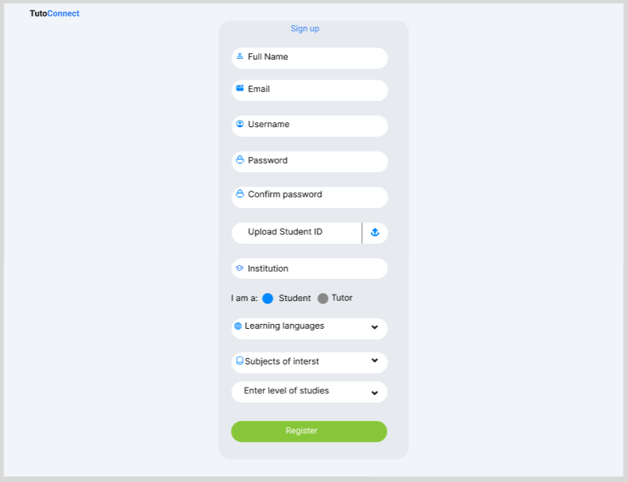
Test 4
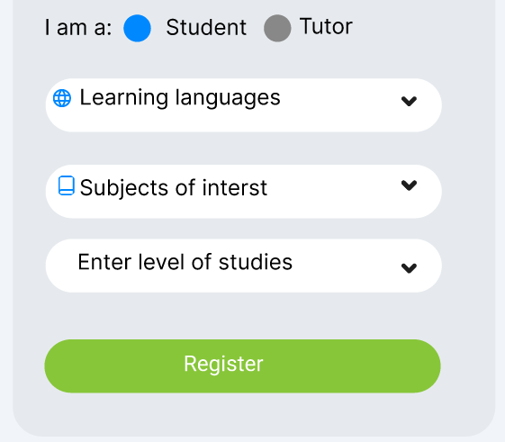
Test 5
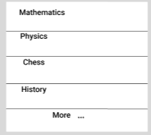
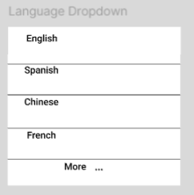
Test 6

Test 7

Test 8
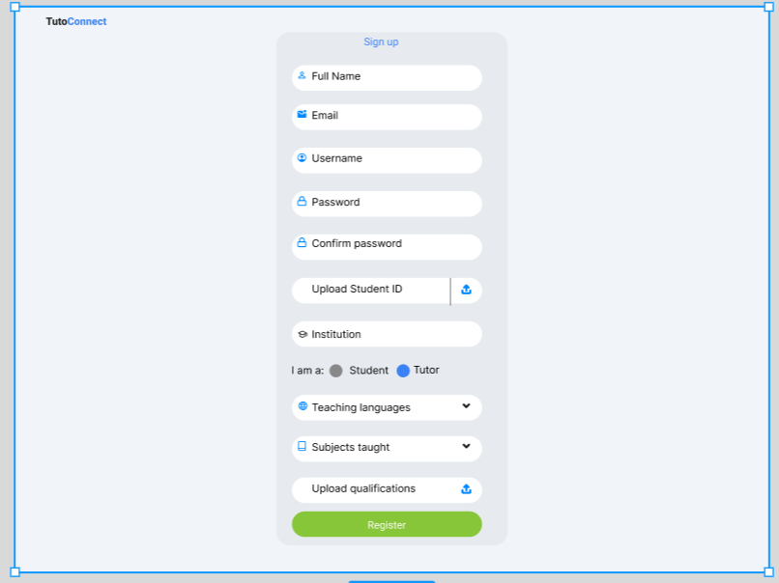
Test 9
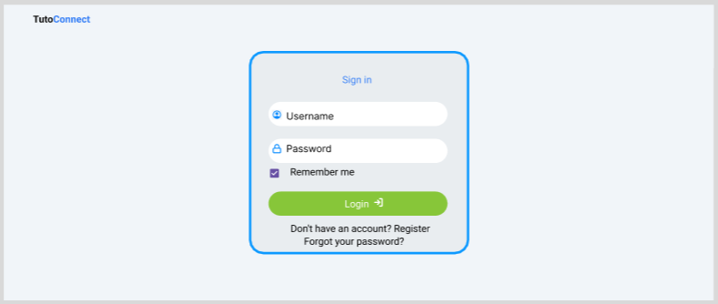
Test 11

Test 12

Test 13
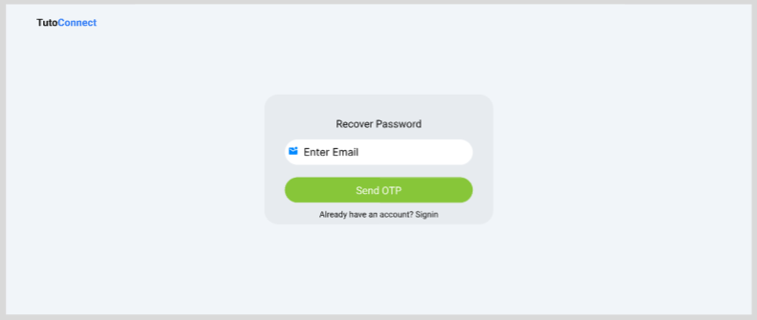
Test 14
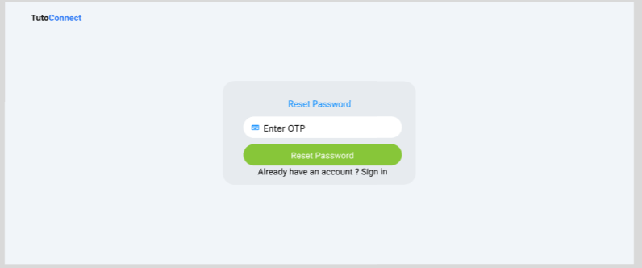
Test 15
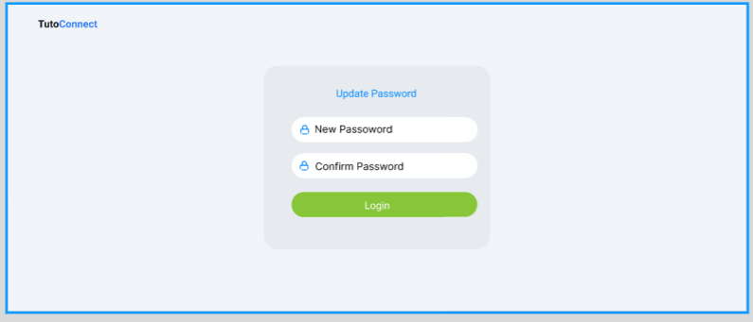
Test 16
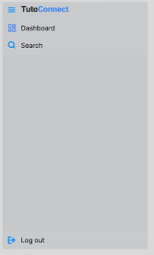
Test 17
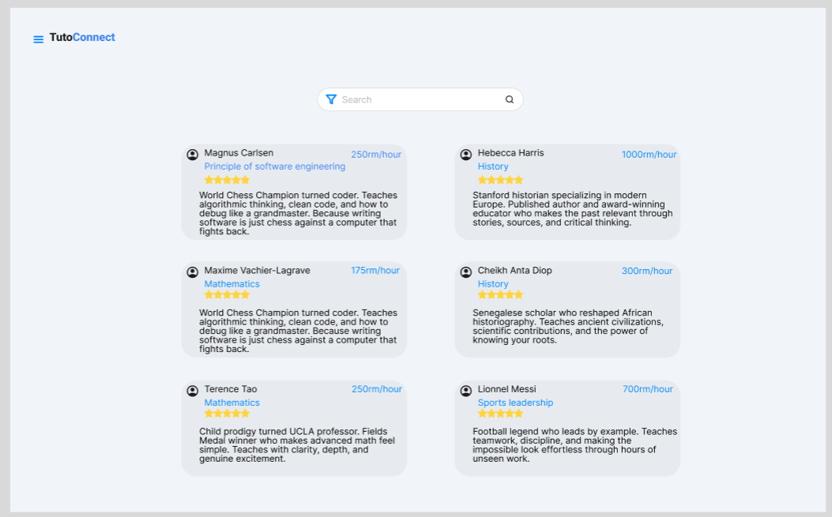
Test 18

Test 19
VVV 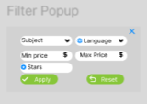
Test 20
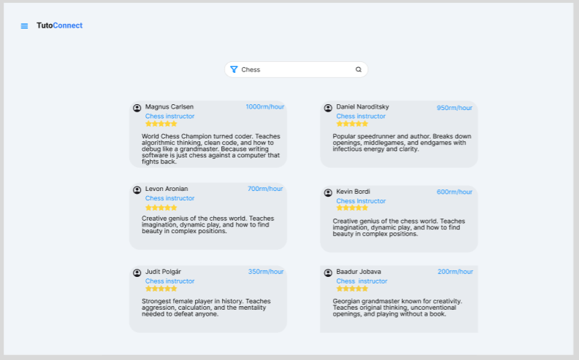

User Feedback

Collection Method
User feedback was collected using the feedback form distributed by Google Forms. Participants were asked to walk though the Sprint 1 prototype screens and answer questions covering the splash screen and registration screens (Section A), the login and session screens (Section B), and the tutor search and filter screens (Section C).
The form was shared with participants after they reviewed the Sprint 1 mockup screens. All responses are recorded in the feedback form using Google Forms. This is the link for the feedback form

Sprint 1 Feedback Form Results
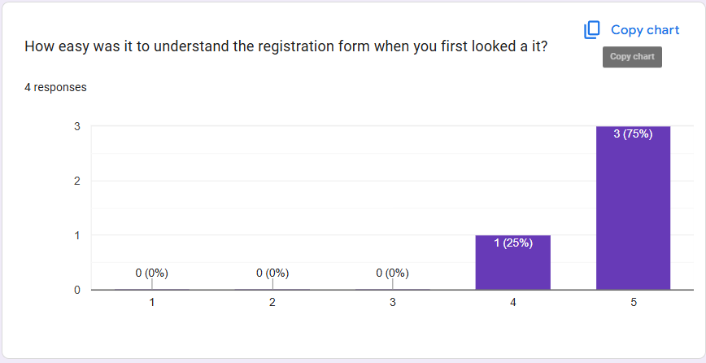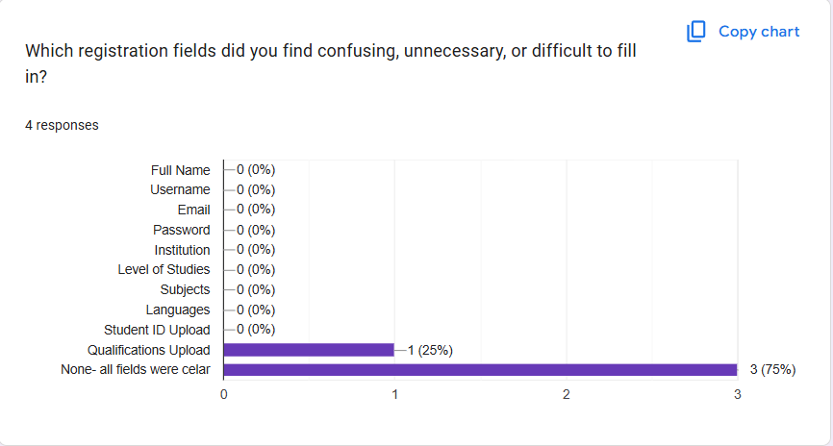
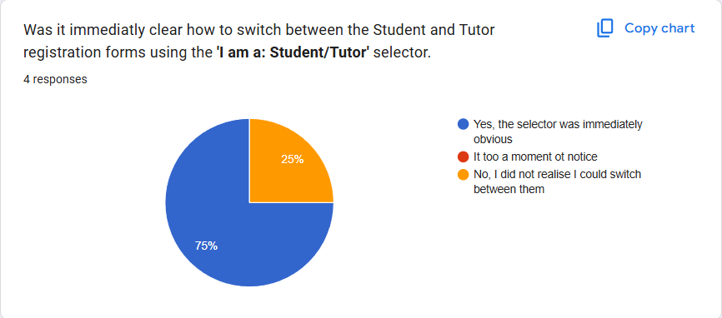
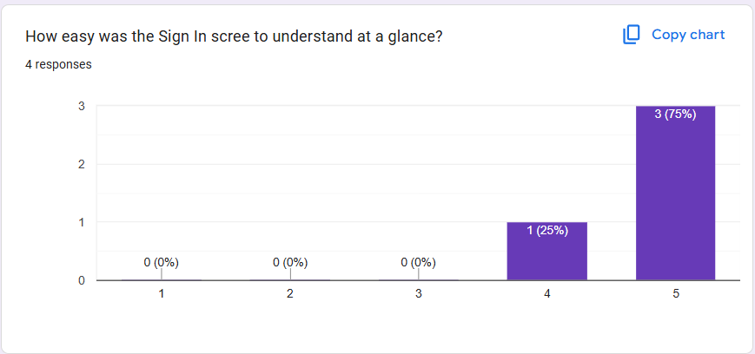
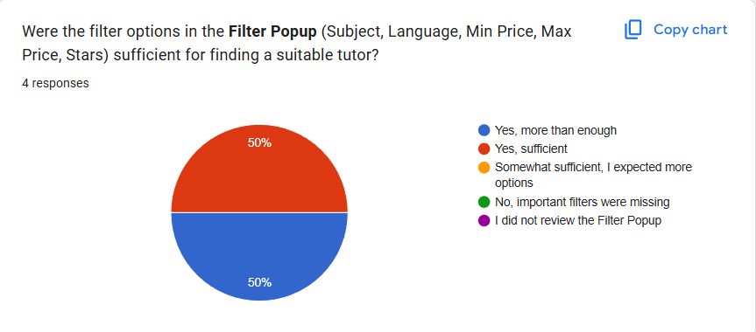
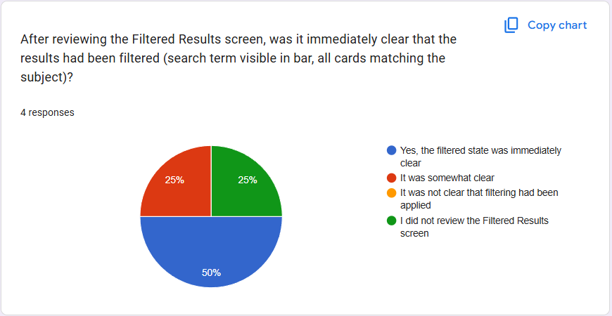
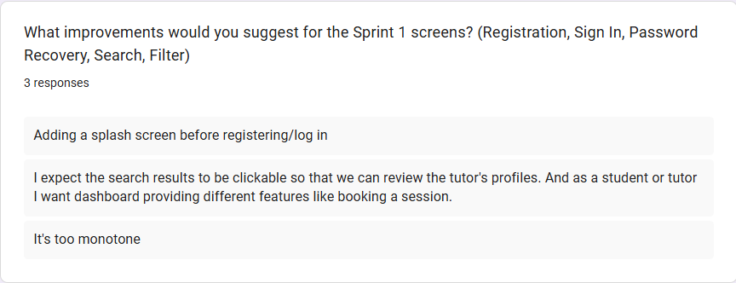

Test Summary

Results
Test Type | Total Tests | Pass | Fail | Pass Rate
User Acceptance Testing | 20 | 17 | 3 | 85%

Failed Tests
Test ID | Description | Impact | Recommended Fix
10 | No error message or error placeholder is visible on the sign in page. Invalid credentials state is not represented. | High; users have no visual feedback when login fails. Without an error message the user cannot tell whether their username or password is invalid. | Add visible error message below the login button to the sign in mockup
1 | Splash screen not implemented | Splash screen is not present | Add splash screen
2 | Splash screen not implemented | Splash screen is not present | Add splash screen

Observations
17 out of 20 Sprint 1 user acceptance tests passed (85%). All other screens contain the expected elements as defined by user stories.
User feedback results from the Google Form will be recorded in Section 3 once participant responses have been collected.

